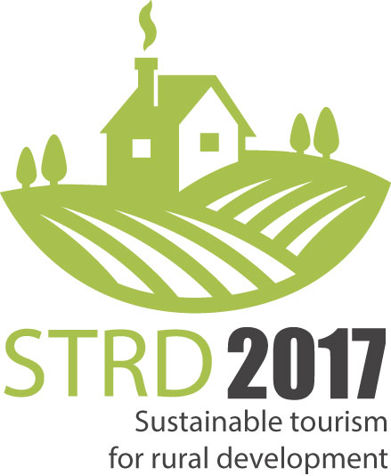Conference and
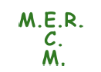Marketplace of Ideas
www.strd2017.org

“Sustainable tourism for rural development”

Rural Tourism is already an important part of the European tourism sector. But many assets and resources for recreation in rural areas are yet not used, or even remain undetected. This conference is a step to broaden the view and unleash the full rural potential for leisure through a holistic approach that includes hospitality, food, gastronomy, culture, active tourism, and any other relevant aspects.

It is a first-ever event that brings together stakeholders from two of the most relevant sectors for the European economy to set common ground for future cooperation and synergies:
- Tourism represents around 10% of European GDP, and is one of the most resilient sectors of EU economy with excellent perspectives of growth.
- 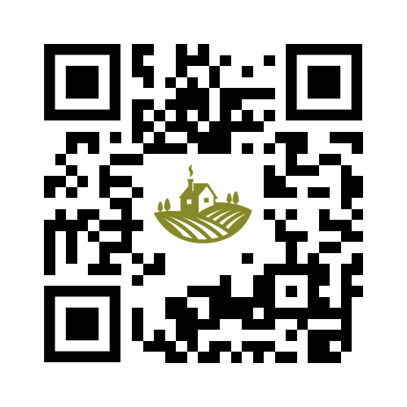92% of EU territory is rural or peri-urban, providing a wide scope of resources and public goods for 743 million habitants in Europe.

In plenary and workgroups, open and dynamic discussion will take place around four topics
- Vitality for smart and competitive rural areas
- Value chains and how to manage them in benefit of rural areas
- The Rural Experience
- Digitalization

On Thursday 16th, each of the above is discussed in a moderated panel, followed by best-practice cases from Europe and Italy. Further 40-50 examples will be presented in a Marketplace of Ideas in the foyer, where participants shall vote for the three most inspiring cases. On Friday 17th, the four topics are discussed in smaller work groups, the results are presented at the closure session where also the winners of the contest from the Marketplace of Ideas shall be announced.

The formal programme is complemented by social events and visit to the Cittá Alta of Bergamo. Participants at the Marketplace of Ideas have the opportunity to present their experience to the general public over the weekend at the AgroTravel & SlowTravel Exhibition .

The organisation is shared between EuroGites-European Federation of Rural Tourism and MER-Mouvement Européen de Ruralité, in the context of the UNWTO “2017 Year of Sustainable Tourism for Development” and the implementation of the Cork 2.0 Declaration . It counts with support of the UNWTO-World Tourism Organisation, ENRD-European Network of Rural Development, COPA-COGECA, EDEN Network, Regione Lombardia, and Ente Fiera Promoberg, amongst others.
Languages: simultaneous translation between Italian and English.
French can be spoken only.
What is the objective?

Raise awareness about the actual and future potential for sustainable tourism and recreation in rural areas by

- Highlighting the wide range of rural resources that can be put into value through recreation and tourism
- Presenting innovative, inspirational, “out-of-the-box”, or even disruptive ideas
- Detecting new potentials for profitable business around them
- Discussing different views and perspectives
- Exchanging views and practical experience across Europe and worldwide
- Establishing new professional and business contacts in the field

Who should participate?

- Decision makers at local, regional, and national levels from the private and public sector
- Rural entrepreneurs with interest in opening new fields and markets for their activity
- Research and training institutions
- …. and in general, anybody involved and committed with lively and vital rural areas in Europe and elsewhere in the world

Summary Schedule

Wednesday, 15-feb Afternoon: set-up of panels for the Marketplace of Ideas at venue
Evening: reception of participants of the Conference

Thursday, 16-feb Full day: plenary sessions
See details below

Friday, 17-feb Morning: plenary session 4
parallel workgroups (4)
See details below
Noon: Results of workgroups, contest, conclusions, closure

Afternoon: individual meetings on arrangement

Saturday 18-feb post-congress tours and peer-to-peer meetings

STRUCTURE
of the plenary sessions on Thursday/Friday

For each of the four topics:
- Introduction by the moderator (5’)
- Moderated panel with 2 experts in the topic, one from the tourism industry and the other from rural development perspective (30 ‘)
- Quick overview of the practical cases that are presented in the Marketplace of Ideas in the foyer (5’)
- One international Best Practice case (10’)
- One Italian Best Practice case (10’)
- Break-the-ice coffee: guided tour to the posters in the Marketplace of Ideas related to the topic, networking opportunities, animation

The Best-Practice cases in plenary will be selected by the Programme Committee by the end of January, and are invited “all cost paid” to the conference.

During Thursday and Friday morning, a “Marketplace of Ideas” with 40-50 practical experiences from Italy and Europe presented on 1x2 mts display posters is set up in the foyer. All participants at the conference shall vote for the most inspiring cases. The three winners will be presented at the Conclusion session on Friday.

CONFERENCE PROGRAMME

Thursday 16-feb Full day: plenary session

9:30 Inauguration and greetings from the hosting Lombardy Region

9:45-11:00 Keynotes for the whole event
UNWTO
ENRD - European Network for Rural Development
EuroGites – European Federation of Rural Tourism
MER – European Countryside Movement
N.N.

11:00 -11:30 Break-the-Ice Coffee: networking, animation

11:30-12:45 1) Vitality: Smart and competitive rural areas
Valorisation of local assets and social dynamics: how can recreation and tourism support the generation of new economies and opportunities that benefit rural areas as a whole. We look not only at rural economy, but the full set of sustainability including social, cultural, and environmental aspects such as
    - food production
    - human capital, infrastructure, image
    - cultural and natural assets (Natura 2000 network etc.)
    - gender opportunities
    - innovation

12:45-14:15 Walking lunch incl. guided tour to the posters or cases at the Marketplace of Ideas related with topic 1

14:15-15.30 2) Value chains and how to manage them in benefit of rural areas
Value chains combining rural resources, tourism, and circular economy: how to optimize the effects of external visitors to rural areas. This includes local cooperation, branding, post-visit sales, or promotion - but also the management of potentially negative impacts such as resource consumption or waste. Core terms are
    - Rural-urban linkages
    - Sales channels
    - Cooperation of structures: CLLD/Leader, DMO, professional organisations, etc.
    - Circular economy

15:30-16:00 Break-the-Ice Coffee 2: guided tour to the posters or cases at the Marketplace of Ideas related with topic 2+3, networking, animation

16:00-17:15 3) The “Rural Experience”
The concept of image, expectations and experience: what does a visitor expect from a visit to the countryside? - how can we know these expectations, define segments, and then address and communicate with the actual and potential customer?
- demand patterns, trends, segments
    - cultural identity and heritage
    - gastronomy and food – from the field to the table
    - active tourism (equestrian, outdoor sports, … )

17:15-17:30 Time to reflect and vote.
Guided tour to the posters or cases related with topic 3. If you already made up your mind about your favourite idea at the Marketplace, this is the moment to vote.

17:30 departure to hotels

19:30 departure from hotels to Conference Dinner at Villa Delizia http://www.agriturismovilladelizia.com

Friday 17-feb

9:00-10:15 4) Digitalization
Digitalization is changing the concepts and channels for communication between providers and clients. It also offers new opportunities for long-term sales connections for local produce. How to make best use of this for organisation, management, development, and marketing of rural areas based on tourism and recreation?
- Consumer based product design and feedback
- Sharing Economy
- Communication: Social Media, Blogs, Web 3.0
- Direct sales and supply of farm produce to urban consumers
- Knowledge transfer - E-Learning in rural areas

10:15-10:45 Coffee – Last occasion to vote!
The last opportunity to vote for the three most challenging and inspiring cases amongst the Marketplace of Ideas (poster displays) in the foyer

10:45-12:30 Work Groups

Work groups shall deal in more detail with core strategic aspects of sustainable tourism and rural development. Results should build on the discussions of the previous day, and focus on practical action to be implemented in the future. Each of them will be moderated by representatives from the partner organisations with most experience in the topic.

Group 1 Vitality Moderation: tbd
Group 2: Value chains Moderation: COPA-COGECA
Group 3: The Rural Experience Moderation: EuroGites
Group 4: Digitalization Moderation: tbd

12:30-13:30 Light Lunch

13:30- 14:30 Presentation of results from Work Groups and
Winners of the contest at the Marketplace of Ideas

14:30-15:00 Closure of the Conference and opening of Fair
Italian authorities (national and regional)
Partner organisations
Patronage entities

Conference Documentation
The full conference documentation will be made available to participants after the event online (with password) and on USB pendrive (tbc).
No printed version is planned, but the full set of electronic documentation will be ISBN registered as electronic publication (tbc).

Participation at the Fair “AgriTravel & SlowTravel Expo”

Registered participants have free access to the fair “AgriTravel & SlowTravel Expo” that begins right after the end of our conference. This includes various opportunities for professional exchange (seminars, workshops, etc.) and business contacts B2B and B2C through a special match-making service of the fair.

Special conditions for participants at the conference apply for individual exhibition space at this fair, as follows:

- Space with individual exhibition panel for posters, shared desk, chair 150 EUR+VAT

- Proper individual stand 3 x 3 mts with desks, chairs, electricity, and
at least 5 panels for decoration 350 EUR+VAT

For more details, you can download the offer here
CALL FOR CONTRIBUTIONS

“Marketplace of Ideas” - Practical cases contest:
- The “Marketplace of Ideas” is an opportunity for innovative, out-of-the-box, or challenging initiatives on sustainable tourism in rural areas from Italy, Europe, and the rest of the world to showcase their experience. We look for consolidated examples that work in reality, but do not exclude ongoing projects if they open new perspectives. Simply introduce your case online HERE - we will then contact you for technical details.
- Cases exposed at this Marketplace of Ideas enjoy a reduced Conference Fee. They shall present their experience in the foyer of the conference with a 1x2 mts poster displays free of cost. These displays will also be placed at the following B2C Fair “AgroTravel & SlowTravel Expo” over the week-end, generating direct impact and possible clients in the future.
- A contest to be voted by the conference participants will select three cases that they consider most inspiring. The winners will be presented during the Conclusions of the conference, and receive refund of their participation cost (maximum 500 EUR).
- Selection by the Programme Committee of two comprehensive cases in each area (one from Italy, one from Europe) for plenary sessions on Thursday 16^{th.} . These selected cases will be invited “all cost paid”, but can NOT participate in the contest.
- Electronic-only presentation (i.e. without participation at the Marketplace of Ideas) is possible, following a standard template (PowerPoint or PDF) that assures a common structure, and thus allows for comparing all cases along the same criteria. These cases will be included in the conference documentation, but cannot participate in the contest.
- Deadlines:
  - 25th-January-2017 for cases to be selected for presentation in plenary
  - 8th-February-2017 for the rest (poster displays, or only electronic)

Panellists for the four sessions in plenary will be invited on private notice. However, if you have an innovative, out-of-the-box, or disruptive view on recreation in rural areas and would like to be part of a panel, we kindly invite to propose yourself at programme@strd2017.org

Papers
Additional to the practical cases, we welcome more comprehensive studies, essays, or articles. They will not be presented in the plenary sessions, but may be used in the WorkGroups on Friday morning, and will be also included in the conference documentation.
Such papers can be sent directly to programme@strd2017.org They should comply with the usual requirements for scientific publications. In case of doubts, please contact the Programme Committee for more detailed technical specifications.
REGISTRATION FEES for international participants:

With registration until 25th-January-2017:
* Members of EuroGites, MER, and practice cases
with poster display at the Marketplace of Ideas 150 EUR
* Members of organisations related with tourism
and rural development 195 EUR
* Other participants in general 250 EUR
* Education and Research Institutions on request

Registration after the 25th-January-2017 will bear a surcharge of 50 EUR

This fee includes the local transfers, congress participation, documentation, full social program and meals from Wednesday evening to Friday afternoon, guided tour to Bergamo Città Alta.

Accommodation is on account of participants, alternative options will be suggested at preferntial rates at two levels (2- and 4-star-hotels) in due course. Orientative rates start at 40 EUR/sgl room incl breakfast

TRAVEL INFORMATION

Bergamo is a city of about 120.000 habitants, situated in centre of the region of Lombardia in the north of Italy. It is set at the foothills of the Alps that begin immediately north of the town. Due to its rich historic and cultural heritage, especially in the UpperTown (“Cittá Alta”) that is still surrounded by Venetian walls, it is the second-most visited city in Lombardia after Milan, which is only 40 kms away.
A guided tour to Bergamo “Città Alta” is included in the registration fee.

ACCOMMODATION can be organised in three alternatives:
- Own arrangement of participants. We suggest to use Booking.com or AirBnb
- Apartment or 1/2 – Star – guesthouses and hotels (starting at 40 EUR/person/night)
- Hotels at 3-4 star level (starting at 60 EUR/person/night)
NOTA: preferential rates including accommodation and breakfast for conference participants at selected hotels will be offered in due course
FREE bus shuttle from the city centre (Piazza Giacomo Matteotti and Railway Station) to the venue at Fiera Bergamo will be available for registered participants at set times.

For AIR TRAVEL we recommend the following options:
- Bergamo “Il Caravaggio” (BGY) airport (4 kms) is the third-busiest airport in Italy and served by many low-cost airlines from all across Europe: RyanAir, Wizz Air, and BlueAir are the most important.
- Milan Malpensa (MXP) is served by all international regular airlines. Direct coach connection several times a day to Bergamo city centre (see here).
- Milan Linate (LIN) is closer to Milan city centre, but no direct public transport to Bergamo is available (only via Milano Centrale railway station).
Transfer from and to Bergamo airport will be arranged for all registered participants free of charge. One free transfer from Milano Malpensa will also be organised in the later afternoon of Wednesday 15th-February. The exact schedules will be defined depending on arrival times of participants.

For arrival by CAR, you find the exact location of the venue “Fiera Promoberg” at the bottom of the website http://strd2017.org

